

**HERITAGE GLOBAL ACADEMY**

2, OLA IYA CLOSE, OFF OKIKI STREET, ISAWO ROAD, OWUTU AGRIC-IKORODU, LAGOS

**1ST CA TEST THIRD TERM EXAMINATION 2023/2024 SESSION**

**SUBJECT: BASIC SCIENCE**

**CLASS: JSS 3** T**IME: 40 MINS**

INSTRUCTION: **Answer ALL questions in Sections A and B**.

**SECTION A**

1. Which of the following cannot produce sound?
2. Guitar
3. Brain
4. Tuning fork
5. Metals
6. Which of the following is part of the outer ear?
7. Stapes
8. Pinna
9. Auditory nerves
10. Hammer
11. The reflection of sound back to the source is called _____
12. echo
13. noise
14. reverberation
15. cacophony
16. The speed of sound in vacuum is
17. 332m/s
18. 1484m/s
19. 5120m/s
20. 0m/s

5. Sound of distorted frequency is called

1. Noise
2. Echo
3. Music
4. Reverberation
5. Lodestone is a _____
6. magnetic rock
7. magnetic plate
8. magnetic field
9. magnetic ray
10. One of the following is a method of magnetization
11. Heating
12. Hammering
13. Induction
14. None of the above
15. Like poles _____
16. Attract
17. Repel
18. Join
19. Contact

1. The following are ways to care for magnet except
2. Should be kept with other magnets
3. Should be kept clean
4. Should be left in hot water
5. None of the above
6. The chemical formula for magnetite is
7. Fe2O3
8. FeO
9. Fe3O
10. Fe3O4
11. The instrument used for measuring electric current is
12. Ammeter
13. Wattmeter
14. Voltmeter
15. Ohmmeter
16. The kind of current generated by EDCN is _____ current
17. parallel
18. series
19. direct
20. alternating
21. ______ is the opposition to electric current
22. Potential difference
23. Electrical power
24. Resistance
25. Fuse
26. A device which is used to prevent power surges from damaging appliances is called
27. Meter
28. Fuse
29. Coil
30. Wattmeter
31. The type of connection commonly used at home is ______
32. parallel
33. series
34. direct
35. alternating
36. A special ability acquired through training is called
37. method
38. process
39. entertainment
40. skill
41. One of the following is not an acquired skill
42. Photography
43. Sleeping
44. Catering
45. Weaving
46. Someone who has acquired a skill is called a
47. Professor
48. Cohesion
49. Profession
50. Professional
51. Which of the following is not a reason for acquiring skills?
52. Survival strategy
53. Dependency on friends
54. Self-employment
55. Training others
56. A person who has little or no knowledge about a particular skill is called
57. Professional
58. Expert
59. Guru
60. Novice
61. The instrument used for measuring electric current is called ______

A. Ammeter

B. Wattmeter

C. Voltmeter

D. Ohmmeter

1. The kind of current generated by EDCN is ______ current

A. Parallel

B. Series

C. Direct

D. Alternating

1. ______ is the opposition to current

A. Potential difference

B. Electrical power

C. Resistance

D. Fuse

1. A device which is used to prevent power surges from damaging appliance is called

A. meter

B. fuse

C. coil

D. wattmeter

1. The type of connection commonly used at home is ______

A. parallel

B. series

C. multiplier

D. shunt

1. A special ability acquired through training is called

A. Method

B. process

C. entertainment

D. skill

1. The chemical formula may be described as ______ of a substance.

A. equation

B. diagram

C. symbol

D. representation

1. One of the following is not an acquired skill

A. Photography

B. Sleeping

C. Catering

D. Weaving

1. Someone who has acquired a skill is called a

A. professor

B. cohesion

C. profession

D. professional

1. Which of the following is not a reason for acquiring skills?

A. Survival strategy

B. Dependency on friends

C. Self-employment

D. Training others

1. A person who has little or no knowledge about a particular skill is called

A. Professional

B. Expert

C. Guru

D. Novice

1. Which of the following is not an example of simple machine?

A. lever

B. pulley

C. bicycle

D. Wheel barrow

1. The efficiency of a machine can be expressed as

$\frac{work input }{work output} x 100$



$\frac{work output }{work input} x 100$

 _________

C. $\frac{work output }{100} x work input$

D. $\frac{100 }{work output} x work input$

1. The part labeled Z in the diagram below is called ___________ .

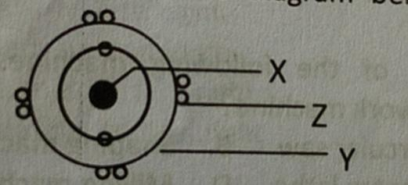

1. Electron
2. proton
3. neutron
4. nucleus
5. The arrangement of first class lever is

A. load between screw and pivot

B. pivot between load and effort

C. effort between pivot and load

D. load between pivot and effort

1. The point where a lever rocks back and forth is the

A. effort

B. load

C. work

D. fulcrum

1. The following are examples of third class lever **EXCEPT**

A. Sugar tong

B. Nutcracker

C. Human forearm

D. Fishing hook

1. The force which propels a space craft round the earth is

A. centripetal

B. centrifugal

C. gravity

D. electrostatic

1. The major factor responsible for juvenile misconduct is ______

A. peer pressure

B. broken home

C. poverty

D. type of siblings

1. The diagram below represents_______ class lever.

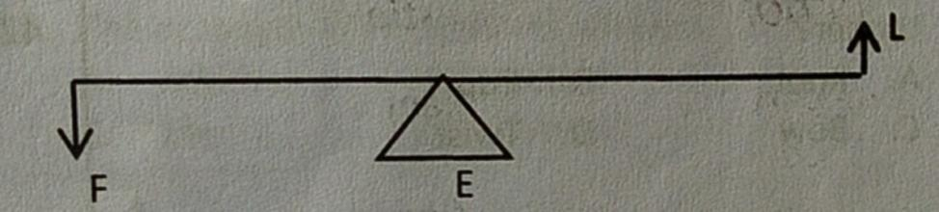

1. first
2. second
3. third
4. fourth